***Classic Gentlemen's Gray Knitted Towels***

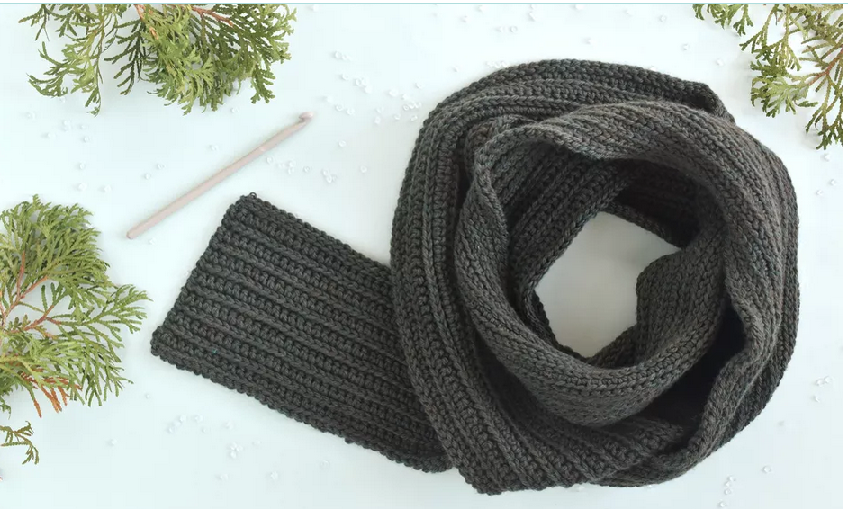

*Fashionable scarves and scarves are always a companion to bring boys and girls new styles in autumn and winter. Not only stopping at classic towels, today there are many new designs and diverse materials born to serve the needs of users.*